Library Name: | cgm
Cell Name: | NOR2XI
Function/Truth Table:
A B |  | Y
0 0 |  | 1
0 1 |  | 0
1 0 |  | 0
1 1 |  | 0
Propagation Delay (path based):
Transition |  | Delay (s)
A → Y ↑ (T_PLH) |  | 1.28n
A → Y ↓ (T_PHL) |  | 1.649n
B → Y ↑ (T_PLH) |  | 1.291n
B → Y ↓ (T_PHL) |  | 1.659n
Output Rise Time (path based):
Transition |  | Rise Time (s)
A → Y ↑ |  | 2.468n
B → Y ↑ |  | 2.489n
Output Fall Time (path based):
Transition |  | Fall Time (s)
A → Y ↓ |  | 3.245n
B → Y ↓ |  | 3.295n
Layout Height:
Layout Width:
Layout Area:
Symbol with Port Names:

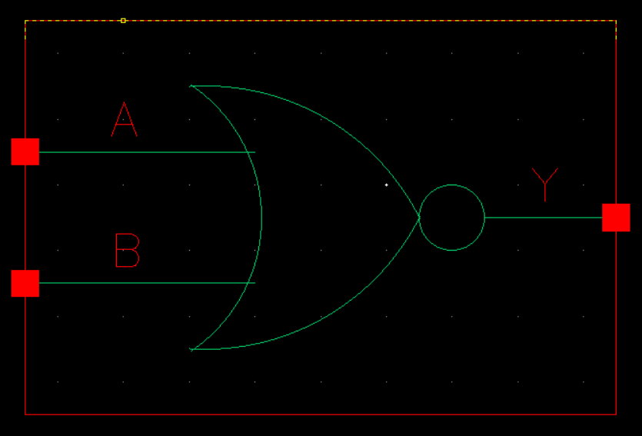
Schematic:

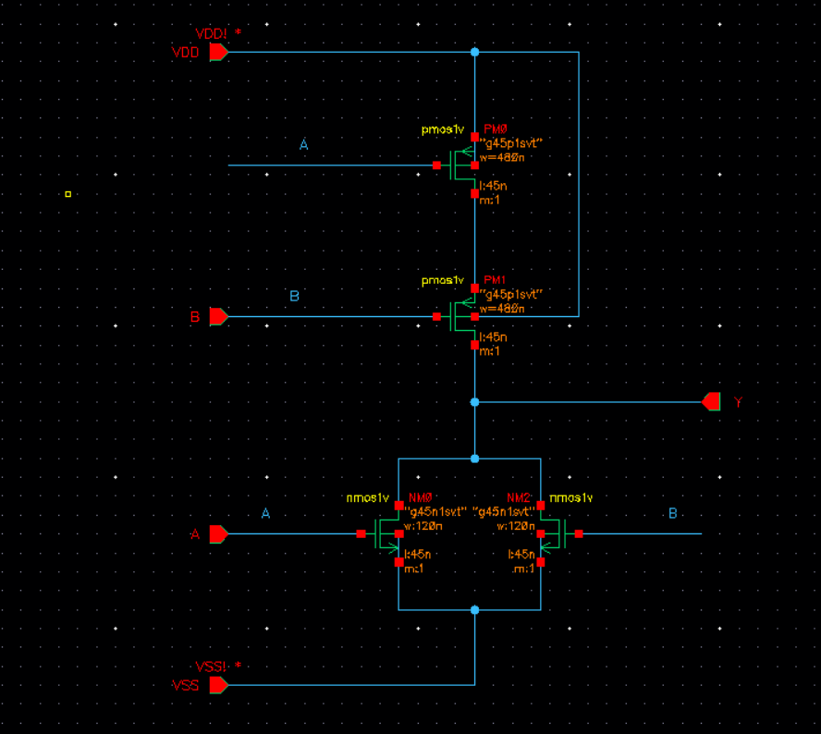
Layout:
Functional Simulation Waveforms

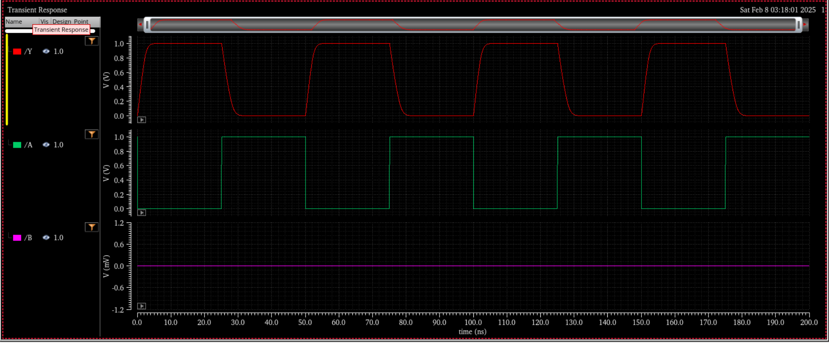

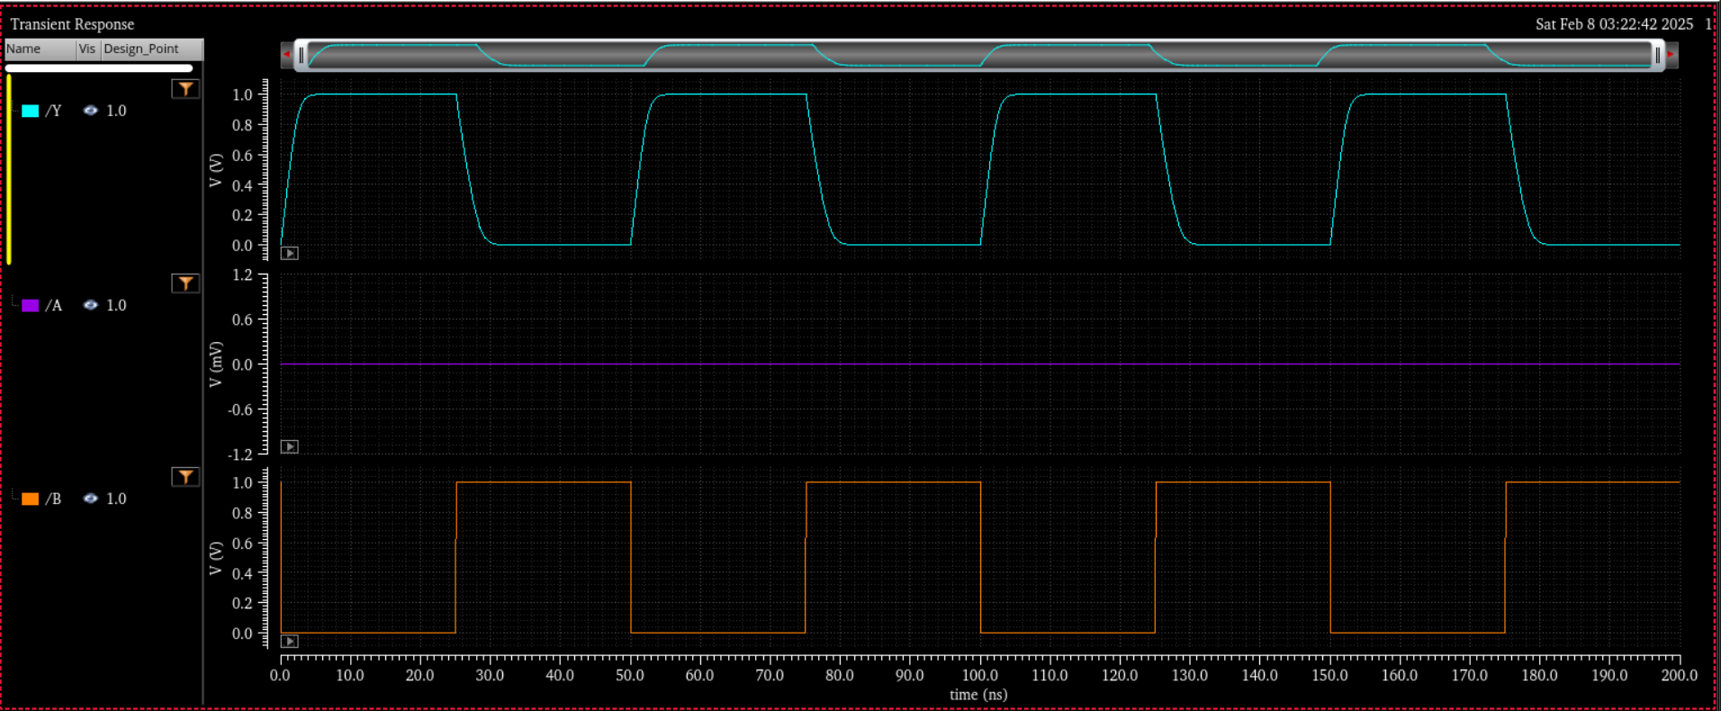

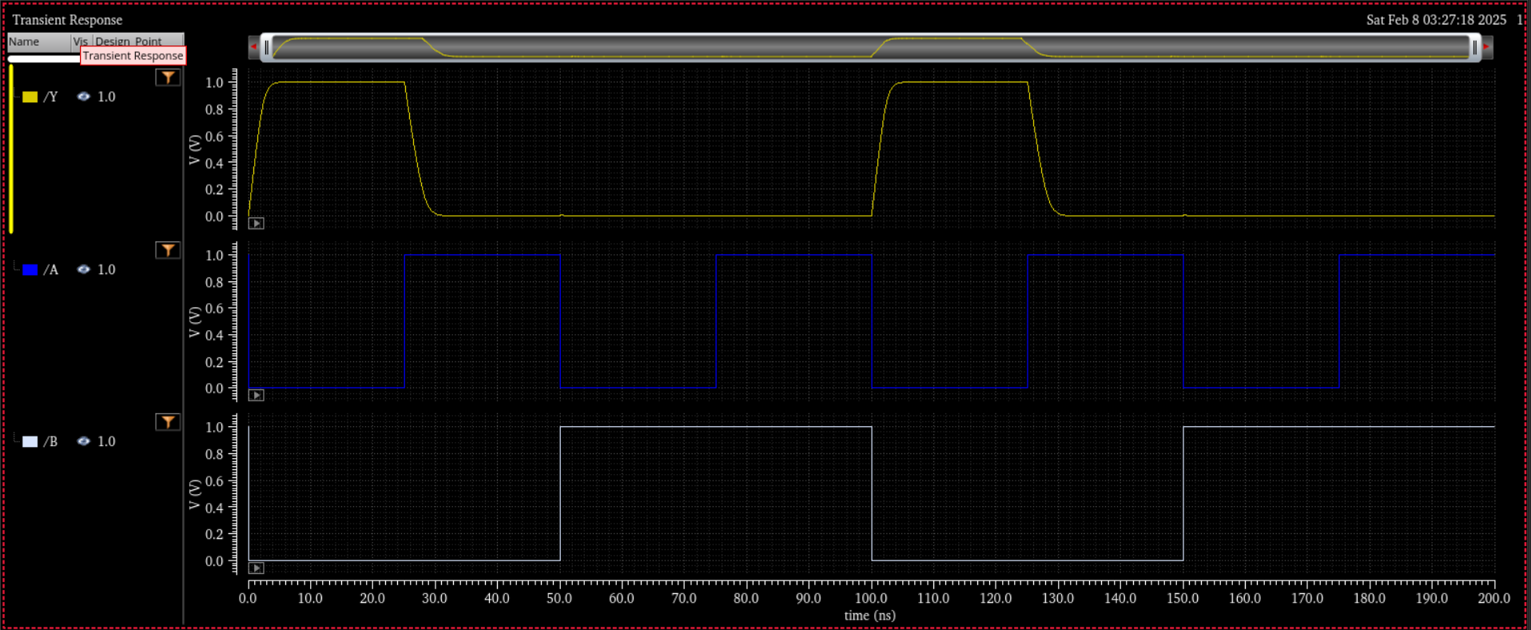
Comments/Notes:

The NOR gate simulation results align with expected values. The propagation delay and rise/fall times are within reasonable limits, with the output responding correctly to changes in the input signals.

